Musical Theater Camp Games Guide

Crossings Community Church – 2024

These are some games that’ve played in previous years that the students seemed to enjoy, plus some new ones to try! Don’t hesitate to adapt the games for your group size, age, etc.

# Notes on Circles

It is a good problem to have, but Musical Theater Camp has grown over the years! Some of these games that call for one large circle might be impractical with 45 students! Games like “Lap, Lap, Clap, Snap”, “One Word Story”, and “Best 8 Count” can be done seated in chairs as well. For the others that really require a circle, you could split the class into two equally sized groups and have two circles play at once.

# The “Frog Game”

I don’t know what this game is actually called, but the campers call it the “Frog Game”. This was probably their favorite game at last summer’s camp!

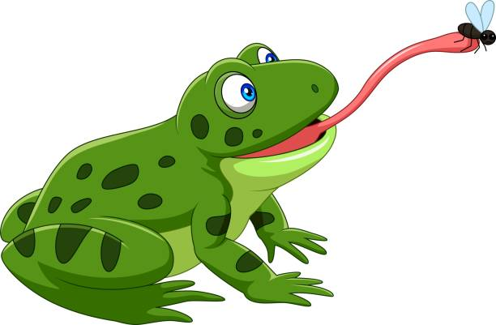

1. Pick one student to be the “hunter” and have them leave the room (or go to a place where they cannot see or hear the rest of the campers).
2. The rest of the students sit in a large circle* facing inward. These are the “flies”.
3. Have the students in the circle lower their heads and close their eyes. A teacher/leader will then silently choose and tap one student on the head. This student is the "frog". They should not reveal that they have been chosen.
4. The students in the circle can then look up and the hunter can return to the room. He or she sits in the middle of the circle.
5. The object of the game is for the hunter to identity the frog by watching the game unfold:
   1. The students should look around the circle, making eye contact with the others.
   2. The frog can make eye contact and quickly stick out their tongue.
   3. When this happens, the fly that they are looking at is out. This “stunned” (eaten) fly can dramatically fall over if they wish.
6. If the hunter identifies the frog before a certain number (anywhere from 5 to 7 is a good number) of flies are “eaten”, the hunter is the winner. If the frog eats the required number of flies before they are caught by the hunter, they are the winner.
7. The game starts over with a new hunter and frog.

*\* See notes on circles on the first page.*

# Lap, Lap, Clap, Snap

This is a great game for the first day or two of camp to help everyone learn each other’s names (including the leaders).

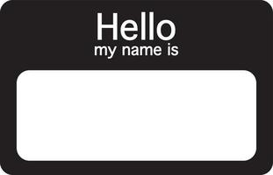

1. All students and leaders sit in a large circle* on the floor.
2. Make a first pass around the circle and have everyone say their names for the rest of the group.
3. Teach the students the pattern, “Lap, Lap, Clap, Snap”. This is done by patting one’s legs with both hands twice in a row, clapping in front of you, and then snapping with both hands. Do it several times until everyone in the circle is comfortable with the rhythm.
4. Once this is done, the leader starts the action: “Lap, Lap, Clap, Snap” but instead of saying “Snap”, the leader then calls out the name of the person next to them in the circle.
5. After the group has gone around the circle once, the game continues but a *random* person in the circle can be named.

The goal is not to break the rhythm of the chant and, once you’ve begun naming random people in the chant, not to repeat any names.

# Boppity Bop

Thanks to Deidra for introducing this game to camp! The game makes an appearance almost every summer!

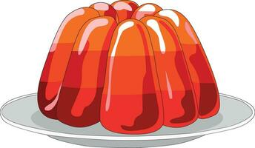

1. The students stand in a single large circle* standing, facing inward.
2. One student (or the leader) starts in the middle of the circle.
3. The “middle” person then chants “boppity-bop-BOP!” and points to a random student in the circle. This student must answer “bop” before the “middle” player has finished their chant.
4. Once the students are comfortable with that, the middle player can then begin pointing to a student in the circle and saying only “bop”. The student pointed to must be silent and not reply.
5. As the game continues, the “middle” person can introduce additional new challenges by pointing and chanting “elephant!” (for example) instead. In this case, the student that is pointed to must make an elephant trunk with their arms and make an elephant noise. The students in the circle to their left and right must also use their arms to make the shape of elephant ears. Some other challenges are:
   1. “House” – the student pointed to must pretend to open a door and step through it while the students to their left and right must make the shape of an angled roof over their head.
   2. “Jell-o” – the student pointed to must jiggle like Jell-o while the students to the left and right must make a circle around them with their arms to look like a bowl for the Jell-o.
   3. “Godzilla” – the student pointed to must stomp and roar while the players to their left and right should pretend to be frightened.
   4. “Toaster” – the student pointed to must crouch down then jump up with their arms in the air, as if they were a piece of toast popping out of the toaster. The players to their left and right use their arms to make a box like a toaster.

**Optional:** After the students have played for a bit, you can choose to play with “eliminations” for students who do not respond in rhythm, make the incorrect motions, etc. Those who are eliminated must step out of the circle. The game continues until there are only two players left.

# Whoosh!

Thanks to Halle for first introducing this game to the students!



Here is how it works:

1. The students (and leaders, if they wish) stand in a single large circle*, facing inward.
2. Starting with one person, the players pretend to pass an invisible ball of energy around the circle, each time chanting “whoosh!” as they hand it to their neighbor.
3. Players may choose from the following additional sounds/gestures:
   1. “Whoa!” – the player puts their hands up facing out. This reverses the direction of passing.
   2. “Zap!” – the player points both hands at another player somewhere else in the circle, who then continues passing the invisible ball. If the receiving player responds with a “Whoa”, the ball returns to the “zapper”.
   3. “Boing” – all players in the circle must quickly crouch down and then back up in a springing motion. Play then continues with the same person passing, zapping, etc.
   4. “Slow-Motion Freakout!” – the player waves their arms in the air. All other players must respond by acting silly, waving their arms, and moving to a new spot in the circle in slow motion. Play continues with the same person then passing, zapping, etc.

# Best 8 Count

This is a good game to play when the campers need to eliminate some wiggles or extra energy.

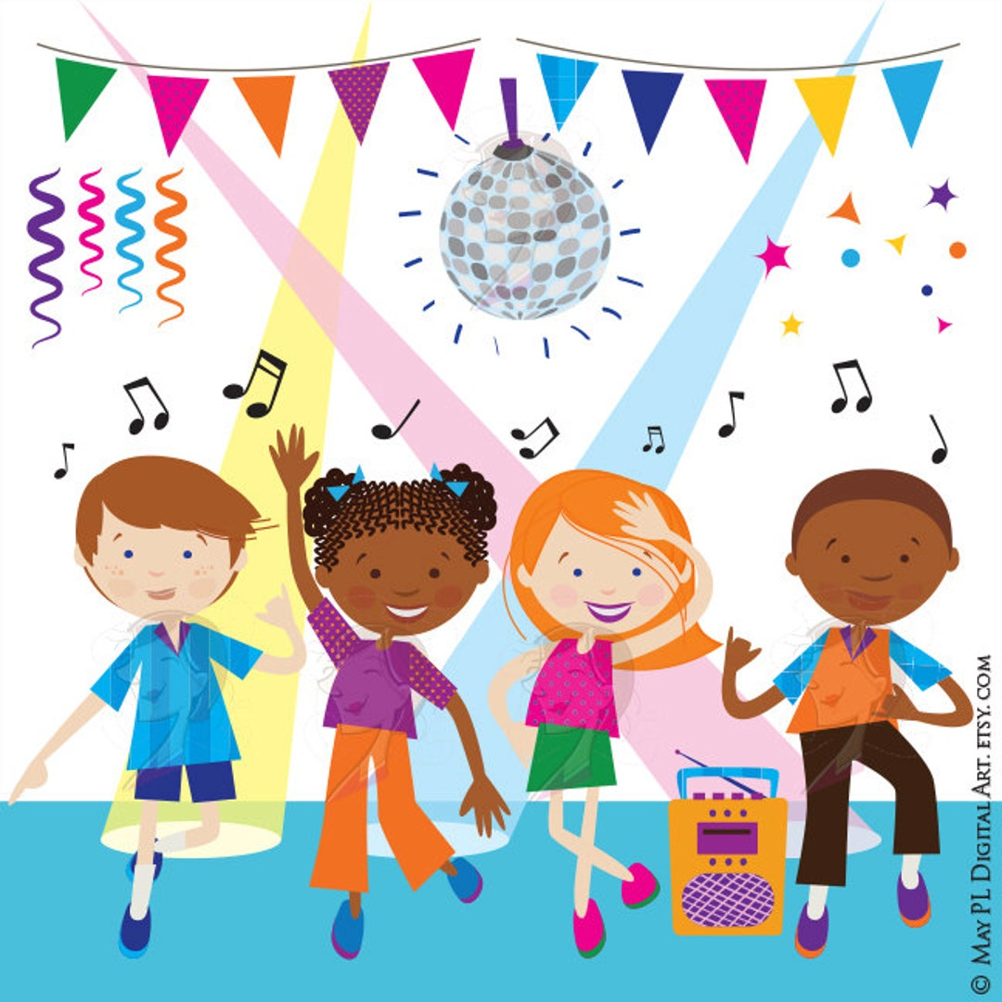

1. Play some upbeat music in your room to start the game.
2. Ask for volunteers, with each student coming up to the front of the room. This student then performs the silliest 8-beat dance routine that they can think of. Let the other students applaud!

Another way to play this game is to let it be a quick activity to do before having the kids sit down. There's no music needed. Just call out "best 8-count! 5-6-7-8” and everyone in the room does their best 8-count at the same time.

# One-Word Story

The object is for the class to tell a coherent story, one word at a time. This is better for older campers.



1. Have the students sit in one large circle*.
2. One student says a single word to begin a story.
3. The person to his or her left says another word, then the next person says another word, continuing around the circle.

The story can be completely silly but must at least make sense (i.e. make sure it doesn’t devolve into “say a random word”).

# Mega Rock, Paper, Scissors – Tournament Edition!

Everyone stands up, finds a partner, and plays rock, paper, scissors. If they lose, they sit back down in their chair. If they win, they find another partner. The rounds repeat until there are only 2 kids left, and they face off to determine the winner!

# Rocker, Rapper, (insert celebrity here)

This is a game like rock, paper, scissors, but with a different name!

* “Rocker” is shown with rocker hands (horns up style)”
* “Rapper” is shown by crossing arms
* The leader can choose the celebrity (e.g. Taylor Swift) or ask the students to nominate one. In the case of Taylor Swift, the players would pretend to hold a microphone.

The rocker beats the rapper, the rapper beats Taylor Swift, Taylor Swift beats the rocker, if you tie you die.

Everyone stands back-to-back with a partner, then chants, "the rocker beats the rapper, the rapper beats Taylor Swift, Taylor Swift beats the rocker, if you tie you die. 5, 4, 3, 2, 1!" On 1, everyone turns around and does their motion. If they lose, they sit down. If they win, they find a new partner. The rounds repeat until only 2 kids are left, and they face off to determine the winner!